Cloud Networks and Their Benefits

* Transition to Cloud Networks:
  + Traditionally, companies owned and managed their network devices on-premises.
  + Now, many companies use third-party providers to manage their networks, helping reduce costs and streamline operations.
* What is Cloud Computing?
  + Involves using remote servers, applications, and network services hosted on the internet instead of local physical devices.
  + Cloud networks store resources and data in remote data centers, accessible via the internet.
* Advantages of Cloud Networks:
  + Saves money by eliminating the need for on-premise network devices.
  + Provides on-demand storage and processing power, with costs based on usage.
  + Offers business and web analytics to monitor traffic and sales.
* Cloud Security Implications:
  + Focuses on verifying both the traffic source and the associated identity.
  + As more organizations migrate to cloud services, securing cloud networks has become a key priority for security professionals.

Cloud computing is transforming network management and security, making it a critical area for modern organizations to understand and implement effectively.

# Cloud computing and software-defined networks

In this section of the course, you’ve been learning the basic architecture of networks. You’ve learned about how physical network devices like workstations, servers, routers, and switches connect to each other to create a network. Networks may cover small geographical areas, as is the case in a local area network (LAN). Or they may span a large geographic area, like a city, state, or country, as is the case in a wide area network (WAN). You also learned about cloud networks and how cloud computing has grown in recent years.

In this reading, you will further examine the concepts of cloud computing and cloud networking. You’ll also learn about hybrid networks and software-defined networks, as well as the benefits they offer. This reading will also cover the benefits of hosting networks in the cloud and why cloud-hosting is beneficial for large organizations.

## Computing processes in the cloud

Traditional networks are called on-premise networks, which means that all of the devices used for network operations are kept at a physical location owned by the company, like in an office building, for example. **Cloud computing**, however, refers to the practice of using remote servers, applications, and network services that are hosted on the internet instead of at a physical location owned by the company.

A cloud service provider (CSP) is a company that offers cloud computing services. These companies own large data centers in locations around the globe that house millions of servers. Data centers provide technology services, such as storage, and compute at such a large scale that they can sell their services to other companies for a fee. Companies can pay for the storage and services they need and consume them through the CSP’s application programming interface (API) or web console.

CSPs provide three main categories of services:

* **Software as a service (SaaS)** refers to software suites operated by the CSP that a company can use remotely without hosting the software.
* **Infrastructure as a service** **(IaaS)** refers to the use of virtual computer components offered by the CSP. These include virtual containers and storage that are configured remotely through the CSP’s API or web console. Cloud-compute and storage services can be used to operate existing applications and other technology workloads without significant modifications. Existing applications can be modified to take advantage of the availability, performance, and security features that are unique to cloud provider services.
* **Platform as a service (PaaS)** refers to tools that application developers can use to design custom applications for their company. Custom applications are designed and accessed in the cloud and used for a company’s specific business needs.

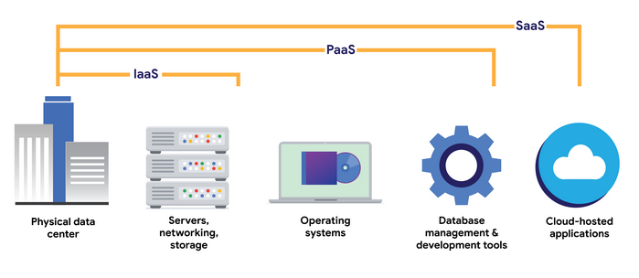

## Hybrid cloud environments

When organizations use a CSP’s services in addition to their on-premise computers, networks, and storage, it is referred to as a hybrid cloud environment. When organizations use more than one CSP, it is called a multi-cloud environment. The vast majority of organizations use hybrid cloud environments to reduce costs and maintain control over network resources.

## Software-defined networks

CSPs offer networking tools similar to the physical devices that you have learned about in this section of the course. Next, you’ll review  software-defined networking in the cloud. Software-defined networks (SDNs) are made up of virtual network devices and services. Just like CSPs provide virtual computers, many SDNs also provide virtual switches, routers, firewalls, and more. Most modern network hardware devices also support network virtualization and software-defined networking. This means that physical switches and routers use software to perform packet routing. In the case of cloud networking, the SDN tools are hosted on servers located at the CSP’s data center.

## Benefits of cloud computing and software-defined networks

Three of the main reasons that cloud computing is so attractive to businesses are reliability, decreased cost, and increased scalability.

### Reliability

Reliability in cloud computing is based on how available cloud services and resources are, how secure connections are, and how often the services are effectively running. Cloud computing allows employees and customers to access the resources they need consistently and with minimal interruption.

### Cost

Traditionally, companies have had to provide their own network infrastructure, at least for internet connections. This meant there could be potentially significant upfront costs for companies. However, because CSPs have such large data centers, they are able to offer virtual devices and services at a fraction of the cost required for companies to install, patch, upgrade, and manage the components and software themselves.

### Scalability

Another challenge that companies face with traditional computing is scalability. When organizations experience an increase in their business needs, they might be forced to buy more equipment and software to keep up. But what if business decreases shortly after? They might no longer have the business to justify the cost incurred by the upgraded components. CSPs reduce this risk by making it easy to consume services in an elastic utility model as needed. This means that companies only pay for what they need when they need it.

Changes can be made quickly through the CSPs, APIs, or web console—much more quickly than if network technicians had to purchase their own hardware and set it up. For example, if a company needs to protect against a threat to their network, web application firewalls (WAFs), intrusion detection/protection systems (IDS/IPS), or L3/L4 firewalls can be configured quickly whenever necessary, leading to better network performance and security.

## Key takeaways

In this reading, you learned more about cloud computing and cloud networking. You learned that CSPs are companies that own large data centers that house millions of servers in locations all over the globe and then provide modern technology services, including compute, storage, and networking, through the internet. SDNs are an approach to network management. SDNs enable dynamic, programmatically efficient network configurations to improve network performance and monitoring. This makes it more like cloud computing than traditional network management. Organizations can improve reliability, save costs, and scale quickly by using CSPs to provide networking services instead of building and maintaining their own network infrastructure.

## Resources for more information

For more information about cloud computing and the services offered, you can review [Google Cloud (GC)](https://cloud.google.com/)

.